Chamber Executive Board Meeting
11:30-12:30
October 2 – Sentry Bank
Attendees: Leslie Lane Kerry Peterson Bob Ringstrom Erica Jodsaas Brad Eckhoff Jude DuHoux
  - Call to Order
  - September Board Meeting Minutes
    - Motion to approve by: Brad
    - Motion seconded by: Leslie
  - September Treasurer’s Report- (Reading & approval of expenses & revenues)
    - Motion to approve by: Bob
    - Motioned seconded by: Kerry
  - Marketing
- Voting: refer to email-Bob to handle during meeting and will be on agenda
- Mill Stream Arts Festival
- BAH – Brenny Transportation-Leslie Attended, they have been billed $50 (Brad)
- Show Your Chamber Pride-SUCCESS
- Facebook
- Added Advertising Rates to the website and submission guidelines
- Added membership listing in pdf format with clickable business links. To come: clickable emails
- Finished Chamber Summary to be sent via Constant Contact (see attached) post on website
- Support each other at next Chamber meeting (phone time)
- Jean Reum/City Hall/Chamber Members
- Marilyn Pate. Southside Historical Articles
- Office Depot Update
- Chamber Bucks, I called Pia and have documented our research in our files
- Changed Hosting/BAH Information to reflect $50
- Newsletter – largest newsletter yet and we had some advertising
- Videos (need to get from Leslie)
- Payment Update: How should these be dealt with? Facetime, Rockhouse, Kennedy
  - I asked Rolling Ridge
    - Chamber Members: Subway, Grilled Cravings, Massage, Crooked Hinges, Becka Brost, Roadway (Patel Rashan)
- Membership Lists and Labels (How should we handle this?)
- New Members / Prospects:
  - Snap Fitness – Deb Seifert
  - October 10 Chamber Meeting
    - Presenter: WACOSA-Roxanne Ryan-Layne
    - Host: BankVista
    - Caterer: Short Stop Custom Catering
  - November 14 Chamber Meeting
    - Presenter: Everyday Wellness, Paul of Mission Nutrition (???)
    - Host: Collegeville Companies
    - Caterer: Gary’s Pizza
  - Misc.
- Hosts/Presenters….Share Your Expertise-SUCCESS, almost filled for next year, suggestions for Sept./Oct/Nov
- Administrative Duties: EDA, Hotel Study review in September, Oct. I’m out of town, try Nov.
- Tarps: 3 for Dave, pd $45, 2 for Kerry, 2 for Tamara (not paid), 1 for Brad (he'll pay) PAID
  - Good of the Chamber (Fan mail, donation requests etc.)
- BAH – possibly Mission Nutrition
- Hosting at the Church – How about Resurrection Church
  - Adjourn
- Motion to adjourn by: Brad
- Motion seconded by: Erica

NO NEED TO READ FURTHER…THIS IS ONLY IF WE HAVE TIME

Call Paula about hosting and BAH
Deb at snap fitness
SPOT tarp
Welcome B&B and Snap Fitness
Dues in November and then again Jan 1 along with Showcase invoicing
1005 st. cloud members
Send list to board member of non businesses?
Deal with bounces
Visitor Coupon Book

Ambassador Program
2 times per month:
Cold Spring Employee Recognition Program ($100 award from Chamber), winner invited to annual meeting
New members (ribbon cutting), anniversary, remodel, open house, grand re-opening
Scheduled (with at least two volunteers)
Visit (1/2 hour)
Framed Certificate

Young Professionals of St. Joseph: A new program of the St. Joseph Area Chamber of Commerce with a goal to target young professionals (age 21-39) in the early stages of their career and offer them professional and social connections within the community as well as a forum for them to voice their opinions.
Winter Trails Map
Permit Usage/Bulk Mail
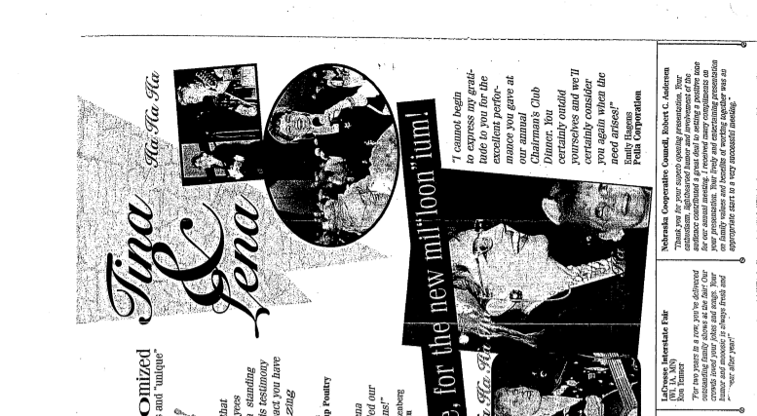

Department of Labor possible speaker: Division of Labor Standards & Apprenticeship - Labor Standards Unit engages employers throughout Minnesota to provide information about state labor standard laws. The Unit oversees state laws regarding wages, youth labor limitations, parental leaves, rest breaks, tips distribution and overtime pay among others We receive about outreach project St. Cloud Office, email: dli.laborstandards@state.mn.us
- Home | Minnesota Department of Labor and Industry\\

