Chamber Executive Board Meeting
11:30-12:30
Tuesday, December 4 – Sentry Bank

Attendees: Leslie Lane Kerry Peterson Bob Ringstrom Erica Jodsaas Brad Eckhoff Jude DuHoux
  - Call to Order
  - November Board Meeting Minutes
    - Motion to approve by:
    - Motion seconded by:
  - November Treasurer’s Report- (Reading & approval of expenses & revenues)
    - Motion to approve by:
    - Motioned seconded by:
  - Marketing
- Agenda for Holiday Meeting?
- Money for solicitation of new members? How much money…I’ll pick relevant companies if you wish.
- Featured Chamber Questionnaire (Roxanne, Leslie, Erica, LouAnn)
- Generic invoices go out the first on November 1, then at the end of November, then purchase stamps
- November 2019 meeting will be at the Fire Hall
- Working on BAH with Mission Nutrition/ Discuss Evening event
- LaPlayette (Shawn and Ann Reisner), Bella, Rolling Ridge, Kay’s Kitchen, Local Blend
- New Members / Prospects:
  - Route 75 Burger Bar
  - Grilled Cravings
  - Massage (Erica, did you speak to her?)
  - Crooked Hinges
  - Roadway -Patel Rashan
  - Good of the Chamber (Fan mail, donation requests etc.)
- Budget review to include Winter Walk
- Morning Meetings?
- St. Joseph Action Group is not renewing
- Support each other at next Chamber meeting (phone time)
- Administrative Duties: EDA
- Remember to let me know of any speaker suggestions (SEO / Professional Words)
  - December 10 Chamber Meeting
    - Presenter: Holiday Gift Exchange
    - Host: No host
    - Caterer: CSB
  - January 14 Chamber Meeting
    - Presenter: Anna Marie’s, Debra Schroeder
    - Host: Premier Real Estate, Kerry Peterson
    - Caterer: Kay’s Kitchen
  - Adjourn
- Motion to adjourn by:
- Motion seconded by:

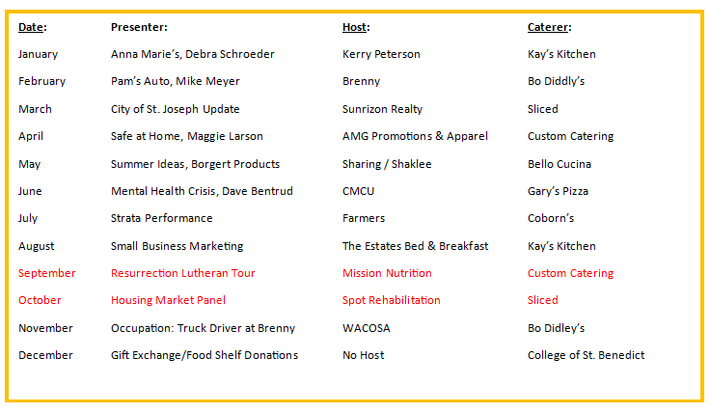
- Office Depot Update/Business Card Rack/Hot Web Deals/Constant Contact Access

NO NEED TO READ FURTHER…THIS IS ONLY IF WE HAVE TIME
1005 St. cloud members
Deal with bounces
Ambassador Program
2 times per month:
Cold Spring Employee Recognition Program ($100 award from Chamber), winner invited to annual meeting
New members (ribbon cutting), anniversary, remodel, open house, grand re-opening
Scheduled (with at least two volunteers)
Visit (1/2 hour)
Framed Certificate

Young Professionals of St. Joseph: A new program of the St. Joseph Area Chamber of Commerce with a goal to target young professionals (age 21-39) in the early stages of their career and offer them professional and social connections within the community as well as a forum for them to voice their opinions.

Winter Trails Map
Permit Usage/Bulk Mail

Discuss Showcase Committee next year

