November Chamber Executive Board Meeting
November 7 – Sentry Bank
Attendees: Kim Poganski Bob Ringstrom Leslie Lane Erica Jodsaas Brad Eckhoff Jude DuHoux
  - Call to Order
  - September Board Meeting Minutes
    - Motion to approve by: Brad
    - Motion seconded by: Kim
  - October Board Meeting Minutes
    - Motion to approve by: Leslie
    - Motion seconded by: Brad
  - September Treasurers Report- (Reading and approval of expenses & revenues)
    - Motion to approve by: Leslie
    - Motioned seconded by: Erica
  - October Treasurers Report- (Reading and approval of expenses & revenues)
    - Motion to approve by: Erica
    - Motioned seconded by: Kim
  - Votes
    - Dues: telling potential and present members (budgeting for next year $125)
      - Motion to raise dues to $125
      - Motion to approve Brad
      - Motioned to Second Kim
    - Quorum – bylaws will be changed to a quorum equaling 3 of 5 board members
  - Good of the Chamber (Fan mail, donation requests etc.)
- Participating in relaunching Chamber Bucks was declined by the board
      - Motion to approve Brad
      - Motioned to Second Kim
- Showcase Date: Propose April 14 (approved) (this is close to last year’s date)
- Agenda Order (with Nominating Committee voting) should be?
- Annual Holiday Meeting agenda
  - CSB will be hosting and catering
  - Entertainment? $25 gift card Piano? Charge for Piano? – No entertainment secured.
  - Program (and agenda)
  - Gift Exchange / Décor / Audio
  - Marketing
- New website page for newsletter
  - Newsletter time (4 hours less)
  - Erica’s Newsletter idea
  - Newsletter: advertising dollars for this month discussion
  - How to deal with St. Joseph Church and advertising and “news”
  - Emails are linked in the newsletter (not paying for website links)
- The Newsleader advertising specialties
  - (Resource Guide $141/July 4th $299/BTS $199/Abduction Awareness $59/Graduation $59)
- New Members:
  - Granite Community Bank-a small community bank located in Cold Spring & Spicer with assets of approximately $100K, 29 full-time employees. www.granitecommunitybank.com
  - Community Technology Center in St. Joseph
- Prospects:
  - Mission Nutrition
- Laurie
  - (320) 654-1502 April Mae Good, AMG Promotions, amgpromotions@charter.net
  - (320) 393-4303 Steve Ree, www.jblunddock.com, sree800800@aol.com
  - (320) 253-6837 Mike Nies (friend of Dave), Nies Electric, nieselectric@gmail.com
  - (320) 557-0190 Paula Weber and Jena Marthaler, Mission Nutrition, coachpaulaw@gmail.com
  - (320) 363-7765 Katrina and Sean Wherry, CentraCare Physicians, Katrina.wherry@centracare.com
  - (320) 363-7765 Subway – Laurie you said you’ve been in contact? Any progress?
- Video Testimonials: have you seen examples?
- Social Share Facebook posts directly from CC, Testimonials, Save The Date, Meetings, Relevant
- Membership Application via Constant Contact
  - November Chamber Meeting
    - November 8, Presenter: Brenda Guggleberger Initiative Foundation, Host: CMCU, Caterer: Gary’s Fire Hall
  - Upcoming Chamber Meeting
    - December 13, Annual Meeting/Holiday Party Presenter: None Caterer: CSB
    - January 10th, Presenter: Colleen Rosenow/Renee Ravendienst, 656-6251, Host: Sanctuary, Caterer: CC
    - Feb 14th, Presenter: Gail Ruchs “Tips on Talking with Parents”, Host: Gail, Caterer: Woodcrest
    - March 14th, Presenter: Stearns County Engineer Issues: Jodi Teich Host: Chris Donley, Facetime

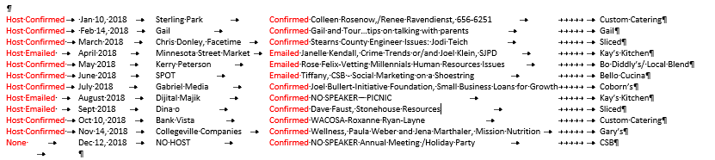
  - Business After Hours
    - The Sanctuary
    - Bello Cucino has declined participating in a BAH
    - The Local Blend and Rockhouse have been approached about a BAH
  - Chamber Administrator update
    - Government Center in 2018 (all dates confirmed with Kayla at City Hall)
    - New Members: The Sanctuary – Scott Ampe-haven’t been paid yet
  - Adjourn
- Motion to adjourn by: Brad
- Motion seconded by: Kim

Advertising Solicitation
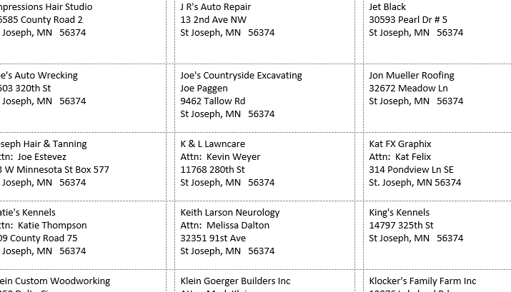

Costs for advertising in our newsletter are:
Sizes: Costs:
Full-page 8”x10.5” $70 / 1/2-page 8”x5” $45 / 1/4-page 3.75”x5” $35
Full-page 8”x10.5” $50 / 1/2-page 8”x5” $25 / 1/4-page 3.75”x5” $15

We reach 256 businesses in St. Joseph with our newsletter. All email addresses are confirmed with no bounces/suspensions/opt-outs. Deadline to let me know you want to participate in monthly advertising is the 20th of each month. Please see attached for an example of our newsletter

