Chamber Executive Board Meeting
11:30-12:30
June 4 – Sentry Bank

Attendees: Leslie Lane X Kerry Peterson X Adam Otteson X Erica Jodsaas X Brad Eckhoff X Jude DuHoux X
  - Call to Order
  - April & May Board Meeting Minutes
    - Motion to approve by: Brad
    - Motion seconded by: Kerry
  - April & May Treasurer’s Report- (Reading & approval expenses & revenues)
    - Motion to approve by: Kerry
    - Motioned seconded by: Leslie
  - Millstream Donation of $400
    - Motion to approve by: Kerry
    - Motioned seconded by: Brad
  - Showcase recap
    - See attached survey sheet
    - American Auxiliary membership dues
  - Marketing
    - New Website navigation and coupon idea
    - Business Card Rack (see ideas on second page) NOT AN OPTION
    - BAM Update
  - (Ann Reisner)/Bad Habit/Local Blend/Kays/McDonalds/Bello/Coborns
  - Newsleaders/SJP/Church of St. Joseph
  - Estates B&B: pdf file to forward to BAM
  - Resurrection: Rootbeer Floats
  - Looking for luggage non-profit
- New Members
- Prospects
  - North Central Truck Accessories
- Top Hatters/Ambassador Program (ribbon cutting), anniversary, remodel, open house, grand re-opening
  - Scheduled (with at least two volunteers)
  - Visit (1/2 hour)
  - Certificate (framed or not framed)
- Young Professionals of St. Joseph: A new program of the St. Joseph Area Chamber of Commerce with a goal to target young professionals (age 21-39) in the early stages of their career and offer them professional and social connections within the community as well as a forum for them to voice their opinions.
  - Good of the Chamber (Fan mail, donation requests etc.)
- Community Center
- Support each other at next Chamber meeting (phone time)
  - June Chamber Meeting
    - Presenter: Dave Bentrud Mental Health Crisis in Policing
    - Host: CMCU Adam Otteson
    - Caterer: Gary’s Pizza
  - July Chamber Meeting
    - Presenter: Strata Performance
    - Host: Farmer’s Insurance
    - Caterer: Coborn’s
  - Adjourn
- Motion to adjourn by: Brad
- Motion seconded by: Adam
REVIEW OF MEMBERSHIP:
Please see attached excel document to discuss at the meeting.

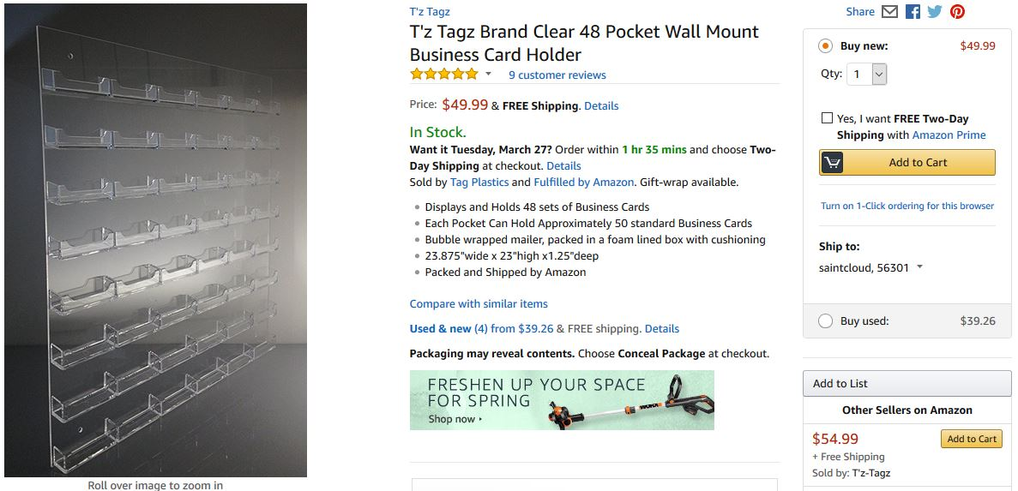

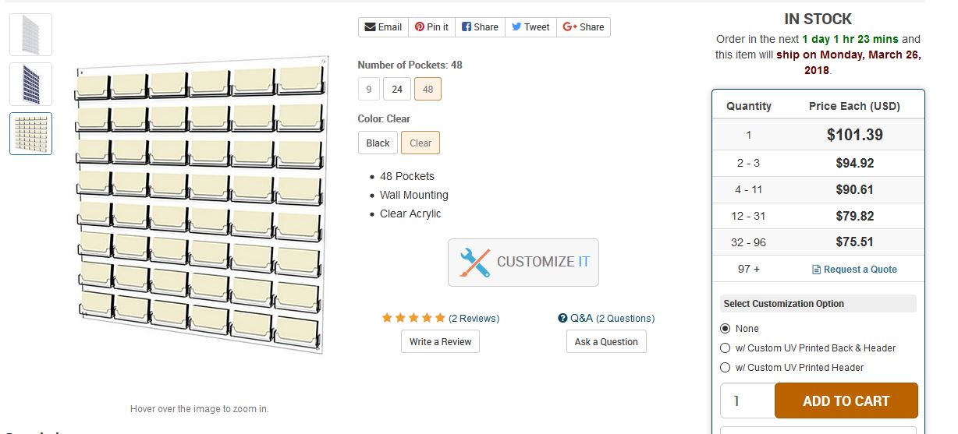

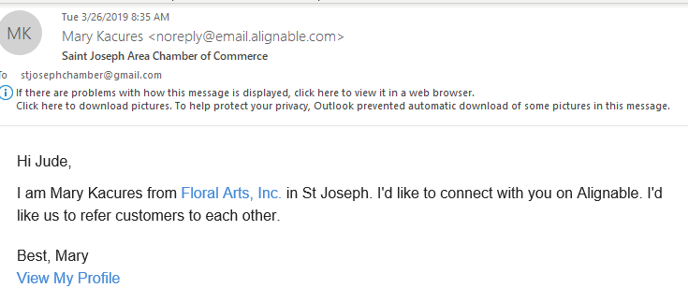

NO NEED TO READ FURTHER…THIS IS ONLY IF WE HAVE TIME

- Office Depot Update/Business Card Rack/Hot Web Deals/Constant Contact Access
1005 St. cloud members
Cold Spring Employee Recognition Program ($100 award from Chamber), winner invited to annual meeting

