January Chamber Executive Board Meeting
January 2 – Sentry Bank

Attendees: Leslie Lane X Kerry Peterson X Bob Ringstrom X Erica Jodsaas X Brad Eckhoff X Jude DuHoux X
  - Call to Order
  - December Board Meeting Minutes
    - Motion to approve by: Brad
    - Motion seconded by: Bob
  - December Treasurer’s Report- (Reading and approval of expenses & revenues)
    - Motion to approve by: Leslie
    - Motioned seconded by: Bob
  - Marketing
- New Members: Welcome Letters sent to
  - Granite Community Bank
  - Pat Schreiber - Mary Kay Independent Beauty Consultant (320)247-0210 pjsmk2@gmail.com
- Newsletter Member feature to launch in January with “The Prep Post” journalists/Susan Kolb
- The Newsleader advertising specialties
- Prospects: Mission Nutrition
  - January Chamber Meeting
    - Presenter: Renee Frauendienst, Public Health. Host: Robin Hadley. Caterer: Short Stop
  - February Chamber Meeting
    - Presenter/Caterer/Host: Woodcrest and Gail Rucks (see Jude’s notes)
  - Good of the Chamber (Fan mail, donation requests etc.)
- Holiday Meeting – received emails on what a great event
- Invoices have been sent and I know people are sending in $ and asking about Showcase
- Food Shelf: will be presented with check in February, Leslie has check Joan Richert 363-7505, ext. 100
- Launching into Showcase Date: April 14
- Bylaws Vote – will be voted on at January’s meeting
- A motion was made to donate $100 to Lake Wobegon Trail
    - Motion to approve by: Kerry
    - Motion seconded by: Brad

  - Adjourn
- Motion to adjourn by: Leslie
- Motion seconded by: Bob
Plans for February at Woodcrest 271-7200. 1200 Lanigan Way. Here’s your opportunity to see Woodcrest. Enjoy a Valentine’s Day Luncheon served by Woodcrest Staff, Gail can do it for $10. As you head south, take a right off College Avenue onto Lanigan Way. Head to 1200 Lanigan Way and park in the parking lot near the Main Entrance. I told Gail about 25 attendees. Tour will take ½ after Gail speaks for just about 10 minutes.
Invoices labels and lists

SHOWCASE:
¼ a “save the date” for showcase will be scheduled to send once I hear back from Eric at Kennedy.
This banner will be added to our website, again, once confirmation is received.
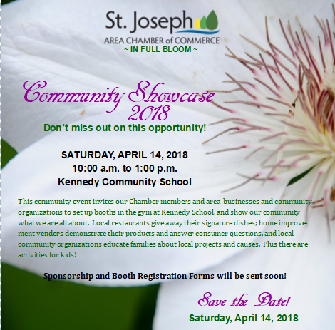

Showcase Theme is “Showcase in full bloom!”

