Chamber Executive Board Meeting
11:30-12:30
November 5 – Sentry Bank

  - Attendees: Leslie Lane Kerry PetersonX Adam OttesonX Brad EckhoffX Sarah Wischnefski Jude DuHouxX
  - Call to Order
  - October Board Meeting Minutes
    - Motion to approve by: Brad
    - Motion seconded by: Adam
  - October Treasurer’s Report- (Reading & approval expenses & revenues)
    - Motion to approve by: Kerry
    - Motioned seconded by: Adam
  - New Member

  - Marketing
    - Nothing…Free advertising in the newsletter sent out a constant contact email
    - 8% click rate Lunch Certificates sent out a constant contact
    - 7% click rate and the only coupons submitted were from non-members
    - Website new format … what should I chase????
    - 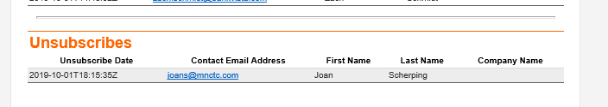
- Prospects
  - North Central Truck Accessories
  - Dairy2U, www.dairy2U.com Brad Hagfors/owner-brad@dairy2U.com
  - Elite Refrigeration Josh Schloemer, 9324 November Drive, St. Jospeh (320) 333-2516
- Top Hatters: I will let you know and come up with an idea…slow intro, no big announcement.
  - Scheduled (with at least two volunteers)
  - Visit (1/2 hour)
  - Certificate (framed or not framed)
  - Showcase
Contacted Nantha for April 11, 18 or 24 (Cold Spring is the first weekend)
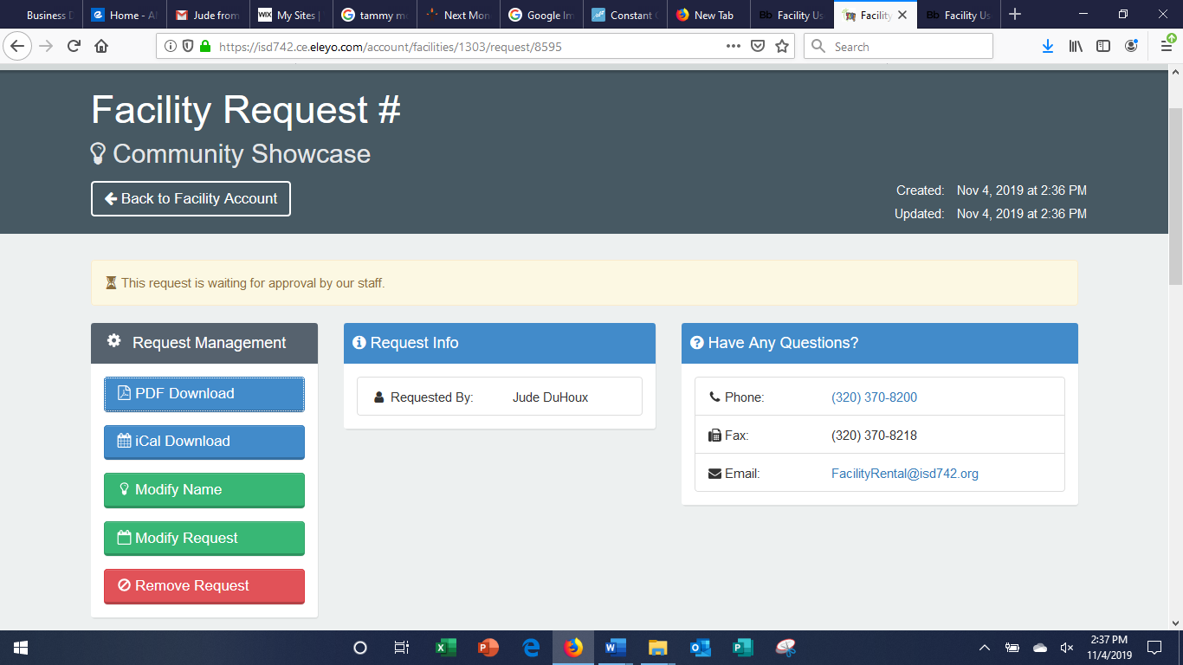

January Wendy Galanius, LSW (Central MN Council on Aging) Senior Linkage Line “Living Options for Seniors”
February State of the City with Kris Ambuehl
March Stearns Electric Solar Energy Solar Farms
April Spot Homecare (320) 259-4151
May Tammy Moore: Perfectly Imperfect Conflict
June Sartell Family Practice Cody Wendlant
July Stearns County Drug Task Force Team
August Dementia Joan Thralow
September Grow Your Business
October Better Sleep
November
December Holiday Party

Managing Risk
Leadership Vicki Ikeogu Johnson
Economics of Historic Preservation
Energy Efficiency, Performance Materials, Insulation, Air Barriers for Your House Retrogreen, Chris Froelke, 320-252-8888

  - Good of the Chamber (Fan mail, donation requests etc.)
- Insurance is Paid (should we review?)
- ByLaws-Bring any changes or updates you may have.
- Joe Prodinsky for VP next year
- Connie Crawley from Floor to Ceiling
- Midco (thank you to Adam)
  - November Chamber Meeting
November: Pastor Jennie Thul
Host: Resurrection Lutheran Church
Caterer: Short Stop
  - December Chamber Meeting
Presenter: NONE Gift Exchange
Host: Farmer’s Insurance, Lori Oppel
Caterer: CSB

- Motion to adjourn by: Brad
- Motion seconded by: Kerry

