Chamber Executive Board Meeting
11:30-12:30
June 5 – Sentry Bank

Attendees: Leslie Lane Kerry Peterson Bob Ringstrom Erica Jodsaas Brad Eckhoff Jude DuHoux
  - Call to Order
  - May Board Meeting Minutes
    - Motion to approve by:
    - Motion seconded by:
  - June Treasurer’s Report- (Reading and approval of expenses & revenues)
    - Motion to approve by: Kerry
    - Motioned seconded by: Bob
  - Marketing
- MCCE information and phone number update
- Remaining brochures have been corrected
- Parade and Joe Town Rocks on our website
- Videos
- 20 old members haven’t paid dues. – same amount as last year? How should these be handled?
  - Floral Arts “we just paid our membership”
  - Kay’s “trade-out”
  - Computers Unlimited “I have the check”
  - Facetime
  - Rockhouse Productions
  - Scenic Specialties
  - Kennedy
  - Subway
- Newsletter Member feature will wait until Fall
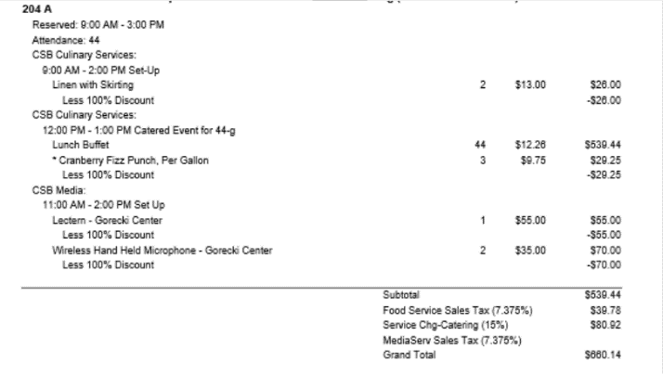
- New Members / Prospects:
  - Doc Mary
  - June Chamber Meeting
    - Presenter: Social Marketing on a Shoestring
    - Host: SPOT Rehabilitation
    - Caterer: Bello Cucina
  - July Chamber Meeting
    - Presenter: Dan Bullert-Initiative Foundation, Small Loans for Growth
    - Host: Gabriel Media
    - Caterer: Coborn’s
  - Good of the Chamber (Fan mail, donation requests etc.)
- BAH
  - Showcase Reconciliation
- Any questions on what Brad sent out?
  - Adjourn
- Motion to adjourn by:
- Motion seconded by:

Mayor Look at fire hall for projector
Showcase Committee next year Lists and Labels
Show Your Chamber Pride Dues go out in November
Dues again Jan 1 along with Showcase invoicing Web Hot Deals
Can a venue host a picnic event? Business Card Rack
Cross Promotions Between Members?
End of the year Chamber Letter (Summary) Flower Project Explanation

